|  |  |  |
| --- | --- | --- |
| **Target Release** |  | |
| **Epic** | <https://bercasaas.atlassian.net/browse/ERP-2056> | |
| **Road Map** |  | |
| **Document Owner** | @Dinda Aprilia Pratiwi | |
| **Designer** | @Dinda Aprilia Pratiwi | |
| **Developer** | @Egi Agus Setiawan Nurdin | |
| **QA** |  | |
| **Enhancement/Refinement** | | **Jira Ticket** | | **Owner** |
| Enhancement   * enhance doctype * update to surat penjaminan | | <https://bercasaas.atlassian.net/browse/ERP-2477> | | @Dinda Aprilia Pratiwi |
| * add amortisasi   **Please pay attention to the red text in this design.** | | <https://project.opusb.co.id/issues/69> | |  |
|  | |  | |  |
|  | |  | |  |

**UI:**

**Document Type**

Menu : Document Type

Window : Document Type

Tab: Document Type

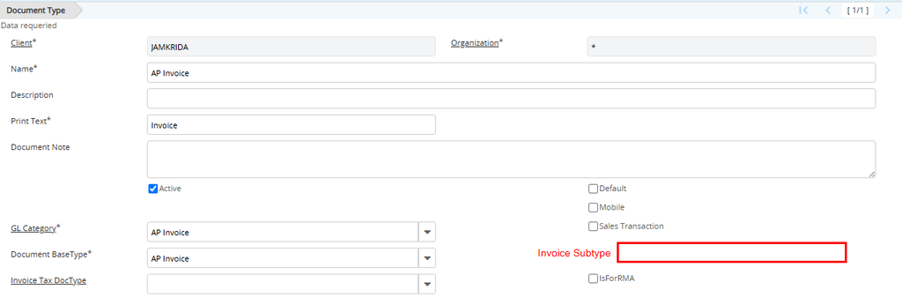

Table : c_doctype

|  |  |  |  |  |
| --- | --- | --- | --- | --- |
| **Column** | **Name** | **Reference Type** | **Reference** | **Notes** |
| Invoice_SubType | Invoice Sub Type | List | * SP/SP Penjaminan * NP/Non SPNon Penjamin * NA/Non Amortize | display logic = y where docbasetype=ARI and API |

**Business Logic**

**Callout on Document Type**

|  |  |  |
| --- | --- | --- |
| **No** | **Trigger** | **Callout** |
|  |  |  |

**Validation on Document Type**

|  |  |  |
| --- | --- | --- |
| **No.** | **Trigger** | **Validation** |
|  |  |  |
|  |  |  |

**Process**

|  |  |
| --- | --- |
| **Trigger** | **Process** |
|  |  |
|  |  |
|  |  |

**Invoice AR (Customer)**

Menu : Invoice AR (Customer)

Window : Invoice AR (Customer)

Tab: Invoice AR (Customer)

c_invoice

|  |  |  |  |  |
| --- | --- | --- | --- | --- |
| **Column** | **Name** | **Reference Type** | **Reference** | **Notes** |
| JMK_SuratPenjaminan_ID | SP No. | Table direct |  |  |
| EndDate | End Date |  |  | =StartDate+JangkaBulan |
| JangkaBulan | Tenor (bulan) | Number  format pattern #,### |  | = StartDate-EndDate(EndDate - StartDate)+1 |
| Total_SYD | Total SYD | Amount |  | =(JangkaBulan+[JangkaBulan+1])/2 (JangkaBulanx[JangkaBulan+1])/2 |
| M_Product_ID | Produk Penjaminan | Search |  | Display = Y where Invoice_SubType. C_DocType **=** SP AND IsSOTrx = Y |

**Business Logic**

**Callout on Invoice AR (Customer)**

|  |  |
| --- | --- |
| **Trigger** | **Callout** |
| Save | * JMK_Amount get from TotalLines * EndDate=(StartDate+JangkaBulan)-1 * JangkaBulan=(EndDate - StartDate)+1 * Total_SYD=(JangkaBulan+[JangkaBulan+1])/2 |

**Validation on Invoice AR (Customer)**

|  |  |  |
| --- | --- | --- |
| **No.** | **Trigger** | **Validation** |
|  |  |  |
|  |  |  |

**Process**

|  |  |
| --- | --- |
| **Trigger** | **Process** |
|  |  |
|  |  |
|  |  |

Menu : **Invoice AR (Customer)**

Window :  **Invoice AR (Customer)**

**Tab: Amortisasi**

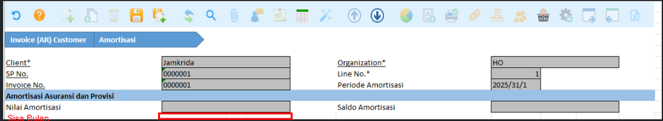

JMK_InvAmt

Read Only=Y, Insert Record=N

|  |  |  |  |  |
| --- | --- | --- | --- | --- |
| **Column** | **Name** | **Reference Type** | **Reference** | **Notes** |
| ad_client_id | Client | Table direct |  |  |
| ad_org_id | Organization | Table direct |  |  |
| JMK _SuratPenjaminan_ID | No. Surat Penjaminan | search ID |  |  |
| c_invoice_id | Invoice No. | search ID |  |  |
| JMK_InvAmt_ID |  |  |  |  |
| JMK_InvAmt_UU |  |  |  |  |
| Created |  |  |  |  |
| CreatedAt |  | Date time |  |  |
| Updated |  |  |  |  |
| UpdatedAt |  | Date time |  |  |
| Line | Line No. |  |  |  |
| DateDoc | Period Amortisasi | date |  |  |
| SisaBulan | Sisa Bulan | Number  format pattern #,### |  |  |
| Amt | Nilai Amortisasi | amount  format pattern #,### |  |  |
| SaldoAmt | Saldo Amortisasi | amount  format pattern #,### |  |  |

**Business Logic**

**Callout on Amortisasi**

|  |  |  |
| --- | --- | --- |
| **No** | **Trigger** | **Callout** |
| 1 | DocAction=CO after complete | IF c_doctype.Invoice_SubType~~!=SP~~ IN (SP,NP)  run call out Process Amortisasi Invoice |
|  |  |  |

**Validation on Amortisasi**

|  |  |
| --- | --- |
| **Triger** | **Validation** |
|  |  |

**Process on Amortisasi**

|  |  |
| --- | --- |
| **Trigger** | **Process** |
| * DocAction=CO after complete | Process Amortisasi Invoice |

* **Process Amortisasi Invoice**

|  |  |  |  |  |
| --- | --- | --- | --- | --- |
| **Column From** | **Table From** | **Column To** | **Table To** | **Notes** |
| ad_client_id | c_invoice | ad_client_id | JMK_InvAmt |  |
| ad_org_id | c_invoice | ad_org_id | JMK_InvAmt |  |
| JMK _SuratPenjaminan_ID | c_invoice | JMK _SuratPenjaminan_ID | JMK_InvAmt |  |
| c_invoice_id | c_invoice | c_invoice_id | JMK_InvAmt |  |
|  |  | JMK_InvAmt_ID | JMK_InvAmt |  |
|  |  | JMK_InvAmt_UU | JMK_InvAmt |  |
|  |  | Created | JMK_InvAmt |  |
|  |  | CreatedAt | JMK_InvAmt |  |
|  |  | Updated | JMK_InvAmt |  |
|  |  | UpdatedAt | JMK_InvAmt |  |
|  |  | Line | JMK_InvAmt | auto num increment 1 (1,2,3 etc) |
|  |  | SisaBulan | SisaBulan | * Line 1= C_Invoice.JangkaBulan * Line n= JMK_InvAmt.SisaBulanline n-1 - 1 |
|  |  | DateDoc | JMK_InvAmt | Start= c_invoice.EOMONTH(StartDate)  run process until DateDoc=c_invoice.EOMONTH(EndDate |
|  |  | Amt | JMK_InvAmt | =(JMK_InvAmt.SisaBulan/c_invoice.Total_SYD) x c_invoice.JMK_Amt |
|  |  | SaldoAmt | JMK_InvAmt | * line 1= jmk_amt- amt line 1 * line 2,n= SaldoAmt(prev row) - Amt |

**Invoice (Vendor)**

Menu : Invoice (Vendor)

Window : Invoice (Vendor)

Tab: Invoice (Vendor)

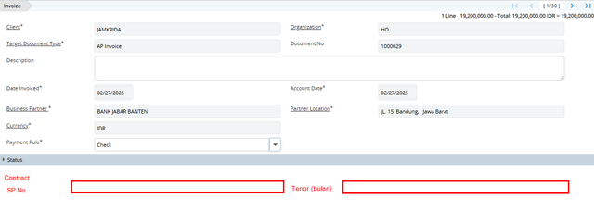

c_invoice

|  |  |  |  |  |
| --- | --- | --- | --- | --- |
| **Column** | **Name** | **Reference Type** | **Reference** | **Notes** |
| JMK_SuratPenjaminan_ID | SP No. | Table direct |  | default where JMK_SuratPenjaminan_ID.Status=AK sort by documentno DESC  display DocumentNo_c_bartner.name |
| JangkaBulan | Tenor (bulan) | Number  format pattern #,### |  | = StartDate-EndDate(EndDate - StartDate)+1 |
| Total_SYD | Total SYD | Amount |  | =(JangkaBulan+[JangkaBulan+1])/2 (JangkaBulanx[JangkaBulan+1])/2 |

**Business Logic**

**Callout on Invoice (Vendor)**

|  |  |
| --- | --- |
| **Trigger** | **Callout** |
| Save | * JMK_Amount get from TotalLines * EndDate=(StartDate+JangkaBulan)-1 * JangkaBulan=(EndDate - StartDate)+1 * Total_SYD=(JangkaBulan+[JangkaBulan+1])/2 |

**Validation on Invoice (Vendor)**

|  |  |  |
| --- | --- | --- |
| **No.** | **Trigger** | **Validation** |
|  |  |  |
|  |  |  |

**Process**

|  |  |
| --- | --- |
| **Trigger** | **Process** |
|  |  |
|  |  |
|  |  |

Menu :**Invoice (Vendor)**

Window :  **Invoice (Vendor)**

**Tab: Amortisasi**



JMK_InvAmt

Read Only=Y, Insert Record=N

|  |  |  |  |  |
| --- | --- | --- | --- | --- |
| **Column** | **Name** | **Reference Type** | **Reference** | **Notes** |
| ad_client_id | Client | Table direct |  |  |
| ad_org_id | Organization | Table direct |  |  |
| JMK _SuratPenjaminan_ID | No. Surat Penjaminan | search ID |  |  |
| c_invoice_id | Invoice No. | search ID |  |  |
| JMK_InvAmt_ID |  |  |  |  |
| JMK_InvAmt_UU |  |  |  |  |
| Created |  |  |  |  |
| CreatedAt |  | Date time |  |  |
| Updated |  |  |  |  |
| UpdatedAt |  | Date time |  |  |
| Line | Line No. |  |  |  |
| SisaBulan | Sisa Bulan | Number  format pattern #,### |  |  |
| DateDoc | Period Amortisasi | date |  |  |
| Amt | Nilai Amortisasi | amount  format pattern #,### |  |  |
| SaldoAmt | Saldo Amortisasi | amount  format pattern #,### |  |  |

**Business Logic**

**Callout on Amortisasi**

|  |  |  |
| --- | --- | --- |
| **No** | **Trigger** | **Callout** |
| 1 | DocAction=CO after complete | IF c_doctype.Invoice_SubType~~!=SP~~ IN (SP,NP)  run call out Process Amortisasi Invoice AP |
|  |  |  |

**Validation on Amortisasi**

|  |  |
| --- | --- |
| **Triger** | **Validation** |
|  |  |

**Process on Amortisasi**

|  |  |
| --- | --- |
| **Trigger** | **Process** |
| * DocAction=CO after complete | Process Amortisasi Invoice AP |

* **Process Amortisasi Invoice**

|  |  |  |  |  |
| --- | --- | --- | --- | --- |
| **Column From** | **Table From** | **Column To** | **Table To** | **Notes** |
| ad_client_id | c_invoice | ad_client_id | JMK_InvAmt |  |
| ad_org_id | c_invoice | ad_org_id | JMK_InvAmt |  |
| JMK _SuratPenjaminan_ID | c_invoice | JMK _SuratPenjaminan_ID | JMK_InvAmt |  |
| c_invoice_id | c_invoice | c_invoice_id | JMK_InvAmt |  |
|  |  | JMK_InvAmt_ID | JMK_InvAmt |  |
|  |  | JMK_InvAmt_UU | JMK_InvAmt |  |
|  |  | Created | JMK_InvAmt |  |
|  |  | CreatedAt | JMK_InvAmt |  |
|  |  | Updated | JMK_InvAmt |  |
|  |  | UpdatedAt | JMK_InvAmt |  |
|  |  | Line | JMK_InvAmt | auto num increment 1 (1,2,3 etc) |
|  |  | SisaBulan | SisaBulan | * Line 1= C_Invoice.JangkaBulan * Line n= JMK_InvAmt.SisaBulanline n-1 - 1 |
|  |  | DateDoc | JMK_InvAmt | Start= c_invoice.EOMONTH(StartDate)  run process until DateDoc=c_invoice.EOMONTH(EndDate |
|  |  | Amt | JMK_InvAmt | =(JMK_InvAmt.SisaBulan/c_invoice.Total_SYD) x c_invoice.JMK_Amt |
|  |  | SaldoAmt | JMK_InvAmt | * line 1= jmk_amt- amt line 1 * line 2,n= SaldoAmt(prev row) - Amt |