|  |  |  |
| --- | --- | --- |
| **Target Release** |  | |
| **Epic** | <https://bercasaas.atlassian.net/browse/ERP-2056> | |
| **Road Map** |  | |
| **Document Owner** | @Dinda Aprilia Pratiwi | |
| **Designer** | @Dinda Aprilia Pratiwi | |
| **Developer** | @Egi Agus Setiawan Nurdin | |
| **QA** |  | |
| **Enhancement/Refinement** | | **Jira Ticket** | | **Owner** |
| New Design | | <https://bercasaas.atlassian.net/browse/ERP-2476> | | @Dinda Aprilia Pratiwi |
| Add amortisasi  **Please pay attention to the red text in this design.** | | <https://project.opusb.co.id/issues/72> | | @Dinda Aprilia Pratiwi |
|  | |  | |  |
|  | |  | |  |

**UI:**

**JMK Surat Penjaminan**

Menu : JMK Surat Penjaminan

Window :  JMK Surat Penjaminan

Tab: JMK Surat Penjaminan

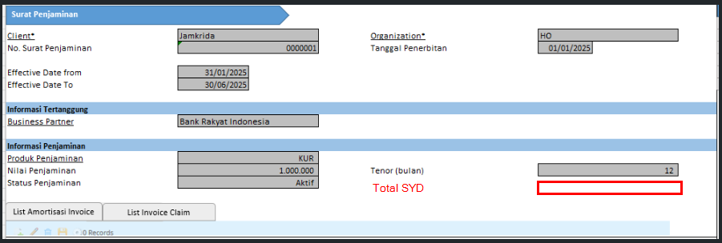

Table : JMK _SuratPenjaminan

|  |  |  |  |  |
| --- | --- | --- | --- | --- |
| **Column** | **Name** | **Reference Type** | **Reference** | **Notes** |
| ad_client_id | Client | Table direct |  |  |
| ad_org_id | Organization | Table direct |  |  |
| JMK _SuratPenjaminan_ID |  | ID |  |  |
| JMK _SuratPenjaminan_UU |  |  |  |  |
| c_bpartner_id | Business Partner | Search | Info window: Business Partner Info |  |
| created |  | Date Time |  |  |
| createdby |  |  |  | default=User Login |
| documentno | No. Surat Penjaminan | String |  |  |
| isactive | Is Active | Yes-No |  | default=Y  display=N |
| revcount | revcount |  |  | display=N |
| updated |  | date time |  | display=N |
| updatedby |  |  |  | display=N  User login |
| DateFrom | Eff. Date From | short date |  |  |
| DateTo | Eff. Date To | short date |  |  |
| Amount | Nilai Penjaminan | amount |  |  |
| CreatedDate | Tanggal Penerbitan | short date |  |  |
| M_Product_ID | Produk Penjaminan | search |  | Mandatory =Y |
| JangkaBulan | Tenor (bulan) | number |  |  |
| JMK_Status | Status Penjaminan | list | New List: JMK Status Penjaminan   * AK/Aktif * PC/Proses Claim * SC/Sudah Diclaim |  |
| Total_SYD | Total SYD | Number |  |  |

**Business Logic**

**Callout on JMK Surat Penjaminan**

|  |  |  |
| --- | --- | --- |
| **No** | **Trigger** | **Callout** |
|  |  |  |

**Validation on JMK Surat Penjaminan**

|  |  |  |
| --- | --- | --- |
| **No.** | **Trigger** | **Validation** |
| 1 | Save | documentno must be unique  “No. Surat Penjaminan sudah ada!” |
|  |  |  |

**Process**

|  |  |
| --- | --- |
| **Trigger** | **Process** |
|  |  |
|  |  |
|  |  |

Menu : JMK Surat Penjaminan

Window :  JMK Surat Penjaminan

**Tab: List Invoice Claim**

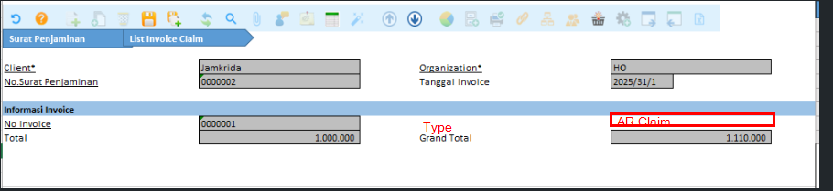

table view c_invoice

Tab Level=1, under JMK_SuratPenjaminan

read only=Y

|  |  |  |  |  |
| --- | --- | --- | --- | --- |
| **Column** | **Name** | **Reference Type** | **Reference** | **Notes** |
| ad_client_id | Client | Table direct |  |  |
| ad_org_id | Organization | Table direct |  |  |
| JMK _SuratPenjaminan_ID | No. Surat Penjaminan | search ID |  |  |
| C_Invoice_ID | No. Invoice | search ID |  |  |
| C_DocType_ID | Type | Table direct |  |  |
| DateInvoiced | Tanggal Invoice | Date |  |  |
| TotalLines | Total | amount |  |  |
| GrandTotal | Grand Total | amount |  |  |

**Business Logic**

**Callout on List Invoice Claim**

|  |  |
| --- | --- |
| **Trigger** | **Callout** |
| open form | select all data from c_invoice where   * docstatus=co * c_doctype.Invoice_SubType=~~SP, NP~~NA |
|  |  |
|  |  |

**Validation on JMK Surat Penjaminan Line**

|  |  |  |
| --- | --- | --- |
| **No.** | **Triger** | **Validation** |
|  |  |  |

**Process on JMK Surat Penjaminan Line**

|  |  |
| --- | --- |
| **Trigger** | **Process** |
|  |  |

Menu : JMK Surat Penjaminan

Window :  JMK Surat Penjaminan

**Tab: List Amortisasi Invoice**

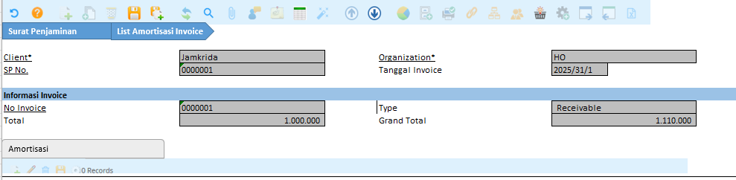

JMK _AmtInvoice

Tab Level=1, under JMK_SuratPenjaminan

|  |  |  |  |  |
| --- | --- | --- | --- | --- |
| **Column** | **Name** | **Reference Type** | **Reference** | **Notes** |
| ad_client_id | Client | Table direct |  |  |
| ad_org_id | Organization | Table direct |  |  |
| JMK _AmtInvoice_ID |  |  |  |  |
| JMK _AmtInvoice_UU |  |  |  |  |
| Created |  |  |  |  |
| CreatedAt |  | Date time |  |  |
| Updated |  |  |  |  |
| UpdatedAt |  | Date time |  |  |
| JMK _SuratPenjaminan_ID | No. Surat Penjaminan | search ID |  |  |
| C_Invoice_ID | No. Invoice | search ID |  |  |
| DateInvoiced | Tanggal Invoice | Date |  |  |
| TotalLines | Total | amount |  |  |
| GrandTotal | Grand Total | amount |  |  |
| InvType | Type | List | new list  Amortisasi Invoice Type   * AR/Receivable * AP/Payable |  |

**Business Logic**

**Callout on List Amortisasi Invoice**

|  |  |  |
| --- | --- | --- |
| **No** | **Trigger** | **Callout** |
| 1 |  |  |
|  |  |  |

**Validation on List Amortisasi Invoice**

|  |  |
| --- | --- |
| **Triger** | **Validation** |
| save | c_invoice_id must be uniqe  “No. Invoice sudah ada” |

**Process on List Amortisasi Invoice**

|  |  |
| --- | --- |
| **Trigger** | **Process** |
|  |  |

Menu : JMK Surat Penjaminan

Window :  JMK Surat Penjaminan

**Tab: Amortisasi**

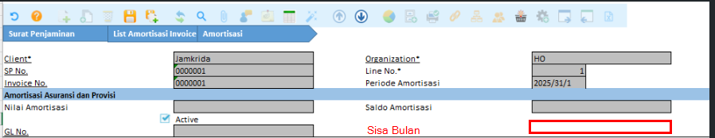

JMK _AmtDetail

Tab Level=2, under JMK_AmtInvoice

|  |  |  |  |  |
| --- | --- | --- | --- | --- |
| **Column** | **Name** | **Reference Type** | **Reference** | **Notes** |
| ad_client_id | Client | Table direct |  |  |
| ad_org_id | Organization | Table direct |  |  |
| JMK _SuratPenjaminan_ID | No. Surat Penjaminan | search ID |  |  |
| c_invoice_id | Invoice No. | search ID |  |  |
| JMK _AmtDetail_ID |  |  |  |  |
| JMK _AmtDetail_UU |  |  |  |  |
| Created |  |  |  |  |
| CreatedAt |  | Date time |  |  |
| Updated |  |  |  |  |
| UpdatedAt |  | Date time |  |  |
| Line | Line No. |  |  | auto num increment 1 (1,2,3 etc) |
| SisaBulan | Sisa Bulan | Number  format pattern #,### |  |  |
| DateDoc | Period Amortisasi | date |  |  |
| Amt | Nilai Amortisasi | amount  format pattern #,### |  |  |
| SaldoAmt | Saldo Amortisasi | amount  format pattern #,### |  |  |
| Gl_journal_id | Gl No. | table direct |  |  |
| IsActive | Active | yes-no |  | default=Y |

**Business Logic**

**Callout on Amortisasi**

|  |  |  |
| --- | --- | --- |
| **No** | **Trigger** | **Callout** |
| 1 |  |  |
|  |  |  |

**Validation on Amortisasi**

|  |  |
| --- | --- |
| **Triger** | **Validation** |
|  |  |

**Process on Amortisasi**

|  |  |
| --- | --- |
| **Trigger** | **Process** |
|  |  |