**Recently Updated**

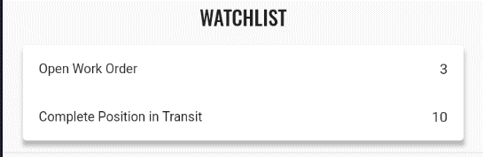

**Bagian diatas diubah**

* **Watchlist 🡪 Recent Items**
* **Item** 
  + **Document Type**
  + **Document No**
* **Process** 
  + **Get recently same on Opusb**

**PM Schedule**

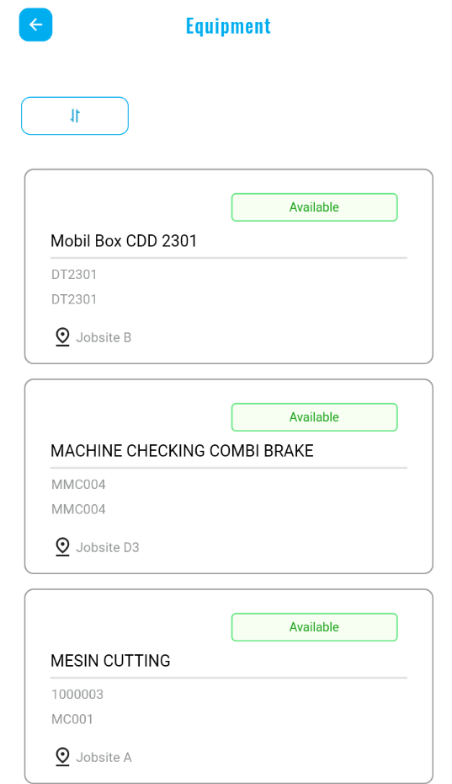 **PM Schedule**

**Add Search Bar**

**Due**

**PM Schedule Name**

**PM Type**

**Equipment**

**Nesxt Scheduled Date**

* **Process** 
  + **Select BHP_PM_Schedule where BHP_PM_Schedule.pm_status = DU**