**Recently Updated**

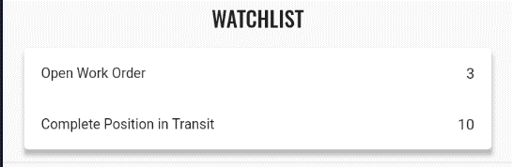

**RECENT ITEMS**

1000001

20/04/2025

Work Order Request – Preventive Maintenance

20/04/2025

**Bagian diatas diubah**

* **Watchlist 🡪 Recent Items**
* **Item** 
  + **Menu**
  + **Document Type**
  + **Document No**
  + **Date**
* **Process** 
  + **Get recently same on Opusb [ 10 Transaction terbaru]**
* **New Table** 
  + **Table : Recent_Trx**

|  |  |  |
| --- | --- | --- |
| **Column** | **Name** | **Notes** |
| Recent_Trx_ID | Recent_Trx_ID |  |
| DocumentNo | Document No | Get DocNo yang diproses |
| C_DocType_ID | Document Type | Get name dari doctype document on process |
| Date | Date | Get Date on process Document |
|  |  |  |