New Special Form: **Budget Info Account**

Apps: <https://poc-1.opusb.co.id/dev/index.zul>

client= DAP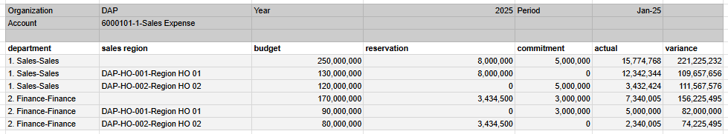

|  |  |  |  |  |
| --- | --- | --- | --- | --- |
| **Column** | **Name** | **Type** | **Ref Type** | **Notes** |
| **Parameter** |  |  |  |  |
| AD_Org_ID | Organization | Table |  | Mandatory=Y  Default ad_org_login |
| c_year_id | Year | Table |  | Mandatory=Y |
| c_period_id | Period | Table |  | Mandatory=Y, where c_year_id=c_year_id<parameter> |
| Account_ID | Account | search |  | Info Account Element  Mandatory=Y |
| **Result** |  |  |  |  |
|  |  |  |  |  |
| User1_ID | Department |  |  |  |
| C_SalesRegion_ID | Sales Region |  |  |  |
| Grouping_Budget |  |  |  | =sum(budget) per user1_id |
| Grouping_Reservation |  |  |  | =sum(Reservation) per user1_id |
| Grouping_commitment |  |  |  | =sum(Commitment) per user1_id |
| Grouping_Actual |  |  |  | =sum(Actual) per user1_id |
| Budget | Budget |  |  | current call out as budget info add grouping by user1_id and c_salesregion_id |
| Reservation | Reservation |  |  | current call out as budget info add grouping by user1_id and c_salesregion_id |
| Commitment | Commitment |  |  | current call out as budget info add grouping by user1_id and c_salesregion_id |
| Actual | Actual |  |  | current call out as budget info add grouping by user1_id and c_salesregion_id |
| Variance |  |  |  | =Budget-reservation-commitment-actual |

Contoh data:

parameter= 6000101-1 Sales Expense