**Process Forecasting Item**

* + - Parameter Process Actual
      * AD_Client_ID [ Client ]
      * AD_Org_ID [ Organization ]
      * M_Product_ID [Product]
      * Start_C_Period [ Start Period] > Zoom in To C_Period
      * End_C_Period [ End Period] > Zoom in To C_Period
    - Parameter Process Actual
      * AD_Client_ID [ Client ]
      * AD_Org_ID [ Organization ]
      * M_Product_ID [Product]
      * Start_Populate_Trx > Zoom in To C_Period
      * Start_Populate_Trx > Zoom in To C_Period
      * Start_C_Period [ Start Period] > Zoom in To C_Period
      * End_C_Period [ End Period] > Zoom in To C_Period
    - New Table : frc_transation

|  |  |  |  |
| --- | --- | --- | --- |
| Column | Name | Type | Notes |
| AD_Client_ID | Client | ID | Default login process |
| AD_Org_ID | Organization | ID | Default login process |
| Frc_type | Forecast Type | Reference |  |
| M_Product_ID | Product | ID |  |
| Trx_date | Transaction Date |  |  |
| Avg_MAD | Average Mean Absolute Deviation | numeric |  |
| Avg_MSE | Average Mean Square Error | numeric |  |
| Avg_MAPE | Average Mean Absolute Percentage Error | numeric |  |
| IsByPass | IsByPass | Y/N |  |
| X | X Value | numeric |  |
| C_Period_ID | Period | ID |  |
| Y | Quantity | numeric |  |
| C_UOM_ID | UOM | ID |  |
| Y’ | Estimasi Qty | numeric |  |
| MAD | Mean Absolute Deviation | numeric |  |
| MSE | Mean Square Error | numeric |  |
| MAPE | Mean Absolute Percentage Error | numeric |  |

* **Process**
  + Forecast Type actual
    - Get (m_inoutline.movementqty) where
      * AD_Client_ID =AD_Client_ID [parameter ]
      * AD_Org_ID =AD_Org_ID [Parameter]
      * C_DocType_ID=1000052
      * M_Product_ID =M_Product_ID [Parameter]
      * m_inout.movementdate > = StartTrx and m_inout.movementdate <= EndTrx [parameter]
    - Mapping on table frc_transation

|  |  |  |
| --- | --- | --- |
| Mapping Column | Name | Notes |
| AD_Client_ID | Client | Same on parameter process |
| AD_Org_ID | Organization | Same on parameter process |
| M_Product_ID | Product | Same on parameter process |
| Trx_date | Transaction Date | Date running process |
| Avg_MAD | Average Mean Absolute Deviation | Get from kalkulasi |
| Avg_MSE | Average Mean Square Error | Get from kalkulasi |
| Avg_MAPE | Average Mean Absolute Percentage Error | Get from kalkulasi |
| X | X Value | null |
| C_Period_ID | Period | Get from kalkulasi parameter |
| Y | Quantity | Get from kalkulasi  sum (movementqty) . rumus diatas. Grouping by period |
| C_UOM_ID | UOM | Get from m_product.c_uom_id wher m_productid =parameter |
| Y’ | Estimasi Qty | Null |
| MAD | Mean Absolute Deviation | Null |
| MSE | Mean Square Error | Null |
| MAPE | Mean Absolute Percentage Error | Null |

* + Forecast Type linear & average
    - Get Forecast Type = act (actual quantity)
      * Get frc_transaction.Y, where
        + Frc_transaction.frc_type = act
        + Frc_transaction.M_product_ID = M_Product_ID[Parameter]
        + Frc_transaction.C_period_id >= StartPeriod[parameter] and C_period_id <= EndPeriod
      * Running calculation dengan data yang sudah ter get di Frc_transaction.frc_type = act and Start_C_Period = Start_C_Period[Parameter] and End_C_Period = Start_C_Period[Parameter]
    - Mapping on Frc_transaction

|  |  |  |
| --- | --- | --- |
| Column | Name | Notes |
| AD_Client_ID | Client | Default login process |
| AD_Org_ID | Organization | Default login process |
| Frc_type | Forecast Type | Same on parameter process |
| M_Product_ID | Product | Same on parameter process |
| Trx_date | Transaction Date | Date running process |
| Avg_MAD | Average Mean Absolute Deviation | Result on calculation |
| Avg_MSE | Average Mean Square Error | Result on calculation |
| Avg_MAPE | Average Mean Absolute Percentage Error | Result on calculation |
| X | X Value | Number period |
| C_Period_ID | Period | Grouping parameter calculation on range Start_c_period[parameter] & End_c_period[parameter] |
| Y | Quantity | Get dari frc_transaction where frc_type= act |
| C_UOM_ID | UOM | M_Product.C_Uom where M_Product_ID = M_Product_ID [Parameter] |
| Y’ | Estimasi Qty |  |
| MAD | Mean Absolute Deviation |  |
| MSE | Mean Square Error |  |
| MAPE | Mean Absolute Percentage Error |  |

**Detail Rumus**

* + Get Coef_y & coef_x
    - Kalkulasi penjualan per period (tY)
      * Penjualan Y x periode[penjualan]
    - Kalkulasi periode kuadrat
      * Periode (t)^2
    - Kalkulasi jumlah penjualan period selama data penjualan
      * Periode (t) > Σ( period1 +periodn)
      * Penjualan Y > Σ(penjualanY(t) period1+…. periodn
      * Ty > Σ (TY period1  +……periodn)
      * T2 > Σ (T2period1  +……periodn)

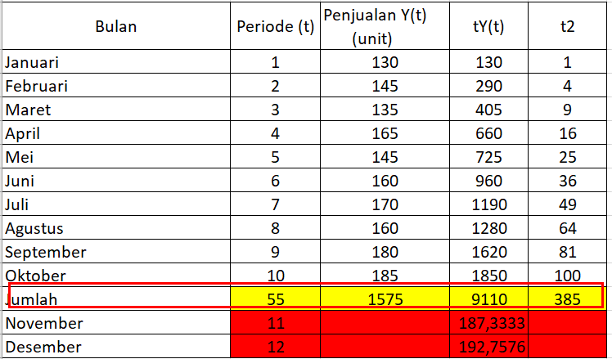

* + - Kalkulasi koefisien
      * b = (Last period x ΣtY) – (Σy x Σt) [coef y]
      * a = (Σt/last period) –((b x Σt) / last period [coef x]
      * persamaan > a + b(t)
  + Y’ (nilai peramalan) 🡪 ( frc_transation.coef_y + frc_transation.coef_x ) * periodn
  + MAD 🡪 (abs(Y-y’)
  + MSE 🡪 (Y- Y’)^2
  + MAPE 🡪 (abs(Y-Y’) /Y