JMK Process Revenue Amortization Calculation

|  |  |
| --- | --- |
| Epic |  |
| Road Map |  |
| Document Owner | Dinda Aprilia Pratiwi |
| Designer | Dinda Aprilia Pratiwi |
| Developer | Egi Agus Setiawan Nurdin |
| QA | Dinda Aprilia Pratiwi |

|  |  |  |
| --- | --- | --- |
| Enhancement/Refinement | Ticket | Owner |
| Origin |  | Dinda Aprilia Pratiwi |

# UI

Menu :Product

Window :  **Product**

**Tab: Accounting**

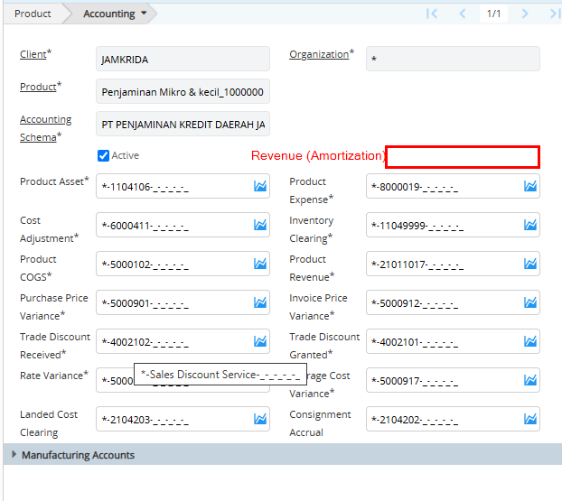

Table: M_Product_Acct

|  |  |  |  |  |
| --- | --- | --- | --- | --- |
| **Column** | **Name** | **Reference Type** | **Reference** | **Notes** |
| JMK_RevenueAmt_Acct | Revenue (Amortization) | Account |  |  |

Menu :GL Journal

Window :  **GL Journal**

**Tab: GL Journal Line**

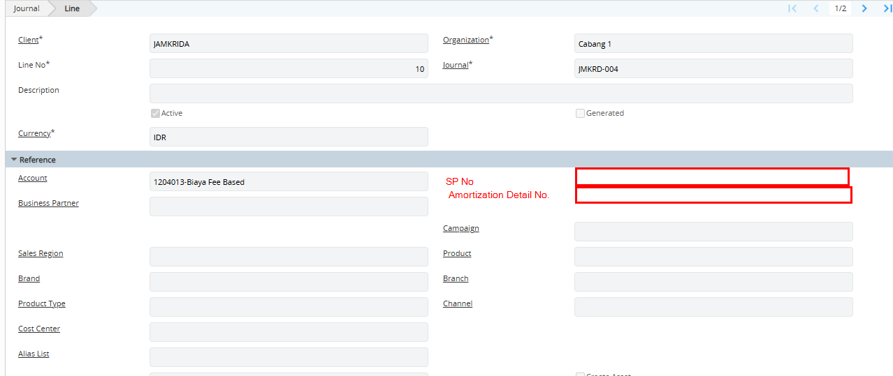

Table: GL_JournalLine

|  |  |  |  |  |
| --- | --- | --- | --- | --- |
| **Column** | **Name** | **Reference Type** | **Reference** | **Notes** |
| JMK_AmtDetail_ID | Amortization Detail No. | Search id |  |  |
| JMK_AmtInvoice_ID | JMK_AmtInvoice_ID | Search id |  | Display=N |
| JMK_SuratPenjaminan_ID | SP No. | Search id |  |  |

Menu: JMK Process Revenue Amortization

Report/Process: JMK Process Revenue Amortization

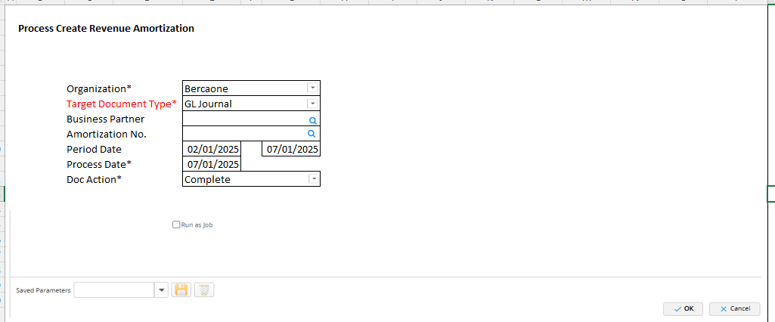

|  |  |  |  |  |
| --- | --- | --- | --- | --- |
| **Column** | **Name** | **Reference Type** | **Reference** | **Notes** |
| **Parameter** |  |  |  |  |
| AD_Org_ID | Organization | Table Direct |  | Default to login  Mandatory=Y |
| C_DocTypeTarget_ID | Target Document Type | Table Direct |  | Default=DocBaseType=GLJ and IsActive=Y  Def Logic= 1003536  Mandatory=Y |
| C_BPartner_ID | Business Partmer | Search ID |  | Business Partner Info (customer) |
| JMK_AmtDetail_ID | Amortization No. | Search ID |  |  |
| DateFrom | Period Date | Short Date |  | =SysDate-7  Mandatory=Y |
| DateTo | To | Short Date |  | =SysDate  Mandatory=Y |
| ProcessDate | Process Date | Short Date |  | =SysDate  Mandatory=Y |
| DocAction | Doc Action | Reference | * CO * IP * DR | Default to CO  Mandatory=Y |

**Business Logic**

Call out in Process JMK Process Revenue Amortization

|  |  |
| --- | --- |
| **Trigger** | **Process** |
| JMK_AmtDetail | New info window  **Parameter**   * ad_org_id/Organization/default login * C_Invoice_ID/Invoice No./String * C_Bpartner_ID/Business Partner/String * DateFrom/Period from/Short Date/Default=SysDate-7 * DateTo/To/Default=SysDate   **Result**   * ic.Documentno/Invoice No * ic.c_bpartner”name”/Business Partner * ad.Line/Line * ad.SisaBulan/Sisa Bulan * ad.DateDoc/Period * ic.JMK_Amount/Nial Penjaminan * ad.Amt/Nilai Amortisasi * ad.SaldoAmt/Saldo Amortisasi   **Call Out**  Select all result from JMK_AmtDetail ad  Join c_invoice ic on ic.c_invoice_id=ad.c_invoice_id  Join JMK_AmtInvoice ai on ai.JMK_SuratPenjaminan_ID=ad. JMK_SuratPenjaminan_ID  Join JMK_SuratPenjaminan sp on sp. JMK_SuratPenjaminan_ID=ad. JMK_SuratPenjaminan_ID  Where   * Ai.Status=AK and * ad_GL_Journal_ID is null and * ad.ad_org_id=ad_org_id<parameter> and * ad.c_invoice_id=c_invoice_id.”documentno”<parameter> if parameter is not null and * sp.c_bpartner_id”name”=c_Bpartner_id<parameter> if parameter is not null and * ad.DateDoc between datefrom<parameter> and dateto<parameter>   Sort By ad.created desc |
|  |  |

**Validation in Process JMK Process Revenue Amortization**

|  |  |
| --- | --- |
| **Trigger** | **Process** |
|  |  |

**Process in Process JMK Process Revenue Amortization**

|  |  |
| --- | --- |
| **Trigger** | **Process** |
| OK | 1. **Select jmk_amtdetail_id**   from JMK_AmtDetail ad  Join c_invoice ic on ic.c_invoice_id=ad.c_invoice_id  Join JMK_AmtInvoice ai on ai.JMK_SuratPenjaminan_ID=ad. JMK_SuratPenjaminan_ID  Join JMK_SuratPenjaminan sp on sp. JMK_SuratPenjaminan_ID=ad. JMK_SuratPenjaminan_ID  Where   * Ai.Status=AK and * ad_GL_Journal_ID is null and * ad.ad_org_id=ad_org_id<parameter> and * ad.jmk_amtdetail_id=jmk_amtdetail_id<parameter> if parameter is not null and * sp.c_bpartner_id”name”=c_Bpartner_id<parameter> if parameter is not null and * ad.DateDoc between datefrom<parameter> and dateto<parameter>  1. **Run process call out GL Journal Amortization** |

**Process call out GL Journal Amortization**

|  |  |  |  |  |
| --- | --- | --- | --- | --- |
| **Column From** | **Table From** | **Column To** | **Table To** | **Notes** |
|  |  |  |  |  |
|  |  | ad_client_id | GL_Journal | login default |
|  |  | ad_org_id | GL_Journal | login default |
|  |  | c_acctschema_id | GL_Journal | 1000073 |
|  |  | c_conversiontype_id | GL_Journal | 1000004 |
|  |  | c_currency_id | GL_Journal | 303 |
| c_targetdoctype_id | <parameter> | c_doctype_id | GL_Journal | 1003537 |
| ProcessDate | <parameter> | c_period_id | GL_Journal | get month and year of ProcessDate then select c_period_id |
|  |  | controlamt | GL_Journal | 0 |
|  |  | copyfrom | GL_Journal | N |
|  |  | created | GL_Journal | sysdate |
|  |  | createdby | GL_Journal | login default |
|  |  | currencyrate | GL_Journal | 1 |
| ProcessDate | <parameter> | dateacct | GL_Journal |  |
| ProcessDate | <parameter> | datedoc | GL_Journal |  |
|  |  | description | GL_Journal | default= " Amortisasi @get month and year from ProcessDate<parameter>", ex: Amortisasi March 2025 |
|  |  | docaction | GL_Journal | CO |
|  |  | documentno | GL_Journal | running num based on docsequence in doctype |
|  |  | gl_category_id | GL_Journal | 1000559 |
|  |  | gl_journal_id | GL_Journal | auto |
|  |  | gl_journal_uu | GL_Journal | auto |
|  |  | isaccrual | GL_Journal | N |
|  |  | isactive | GL_Journal | Y |
|  |  | postingtype | GL_Journal | A |
|  |  | totalcr | GL_Journal | default where sum gl_journaline.AmtAcctCr |
|  |  | totaldr | GL_Journal | default where sum gl_journaline.AmtAcctDr |
|  |  | updated | GL_Journal | sysdate |
|  |  | updatedby | GL_Journal | login default |
|  |  | versionno | GL_Journal | 1 |
|  |  | a_createasset | GL_JournalLine | N |
|  |  | a_processed | GL_JournalLine | N |
| P_Revenue_Acct | M_Product_Acct | account_id | GL_JournalLine | If amtacctdr is not null |
| JMK_Revenue_Acct | M_Product_Acct | account_id | GL_JournalLine | If amtacctcr is not null |
| ad_client_id | GL_Journal | ad_client_id | GL_JournalLine |  |
| ad_org_id | GL_Journal | ad_org_id | GL_JournalLine |  |
| amt | JMK_AmtDetail | amtacctcr | GL_JournalLine | If amtacctdr is not null set to 0 |
| amt | JMK_AmtDetail | amtacctdr | GL_JournalLine | If amtacctcr is not null set to 0 |
| amt | JMK_AmtDetail | amtsourcecr | GL_JournalLine | If amtacctdr is not null set to 0 |
| amt | JMK_AmtDetail | amtsourcedr | GL_JournalLine | If amtacctcr is not null set to 0 |
| c_bpartner_id | JMK_SuratPenjaminan | c_bpartner_id | GL_JournalLine |  |
| c_currency_id | GL_Journal | c_currency_id | GL_JournalLine |  |
| c_uom_id | m_product.GL_Journal | c_uom_id | GL_JournalLine |  |
|  |  | c_validcombination_id | GL_JournalLine | auto |
|  |  | created | GL_JournalLine | sysdate |
|  |  | createdby | GL_JournalLine | login default |
|  |  | currencyrate | GL_JournalLine | 1 |
| ProcessDate | <parameter> | dateacct | GL_JournalLine | 2025-01-09 00:00:00.000 |
|  |  | description | GL_JournalLine | default= " Amortisasi @get month and year from DateDoc.JMK_AmtDetail@ @DocumentNo.JMK_SuratPenjaminan@", ex: Amortisasi March 2025 SP-110001 |
| gl_journal_id | GL_Journal | gl_journal_id | GL_JournalLine |  |
|  |  | gl_journalline_id | GL_JournalLine | auto |
|  |  | gl_journalline_uu | GL_JournalLine | auto |
|  |  | isactive | GL_JournalLine | Y |
| isgenerated |  | isgenerated | GL_JournalLine | N |
|  |  | line | GL_JournalLine | auto increment 10 |
| m_product_id | JMK_SuratPenjaminan | m_product_id | GL_JournalLine |  |
|  |  | updated | GL_JournalLine | sysdate |
|  |  | updatedby | GL_JournalLine | login default |
| JMK_AmtDetail_ID | JMK_AmtDetail | JMK_AmtDetail_ID | GL_JournalLine | New column |
| JMK_AmtInvoice_ID | JMK_AmtDetail | JMK_AmtInvoice_ID | GL_JournalLine | New column |
| JMK_SuratPenjaminan_ID | JMK_AmtDetail | JMK_SuratPenjaminan_ID | GL_JournalLine | New column |

**Data Simulation (excel JML Process Revenue Amortization 1, sheet simulasi)**

